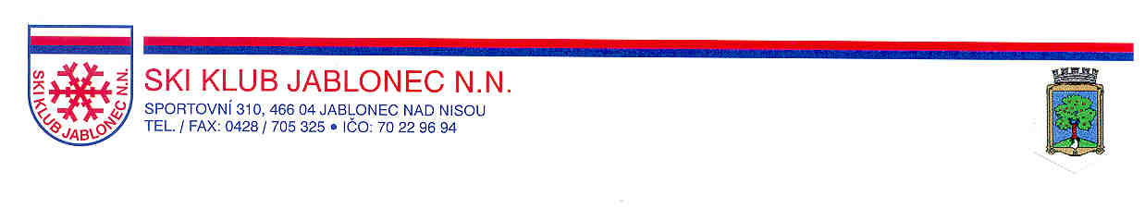

FIS Rollerski
European Championships
and
World Cup
Jablonec n.Nisou
20.6 – 22.6.2003

INVITATION

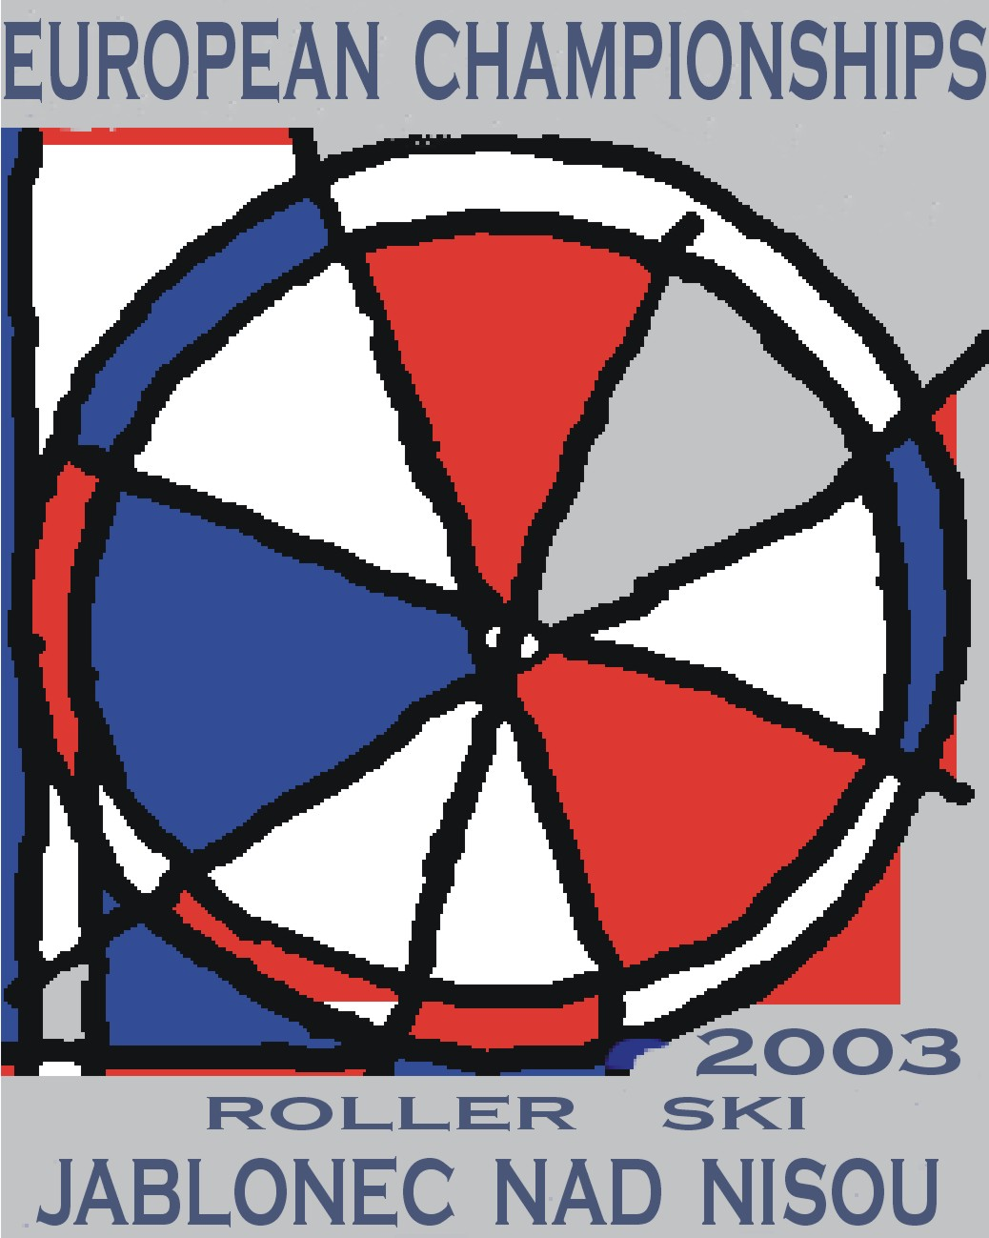

The Czech Ski Association in cooperation

with the Ski klub Jablonec nad Nisou

invites you to participate in
FIS Rollerski
European Championships
and
Word Cup

in Jablonec nad Nisou
June 20th – 22nd, 2003

Organizer : Czech Ski Association
Technical execution : SKI KLUB Jablonec nad Nisou
Date of a competition : 20. - 22. 6. 2003
Entries / address : the organizers must receive entry forms
at the latest - June 6th, 2003
SKI KLUB Jablonec nad Nisou,
Sportovní 310, 466 04 Jablonec nad Nisou
Tel.: ++420 483 705 860
Tel./FAX : ++420 483 705 590,
++420 483 705 325
E-mail : slcr.lyze.beh@pvtnet.cz
Accreditation (attendance) : June 19th, 2003
10,00 – 15,00 o’clock
Ski - Centrum SK Břízky
Sportovní 310, Jablonec nad Nisou
Boarding and lodging : The fixed numbered announcement, separated by women and men, has to be made by June 6th at the latest with the attached formulaire or e-mail.
SKI KLUB Jablonec nad Nisou, Sportovní 310, 466 04 Jablonec nad Nisou
Tel./FAX : ++420 483 705 590,
++420 483 705 325
E-mail : slcr.lyze.beh@pvtnet.cz

Accommodation costs will be paid by the Organizing Committee according to the FIS rules (3 days full board for the seeded group)
The costs have to be paid directly to the Organizing Committee during the accreditation (19.6.2003) and are following ones:
A/ 35,- EU
B/ 25-30,- EU
C/ 15-25,- EU
The Organizing Committee can not guarantee accommodation if your forms should arrive later than 6.6.2003
Competition office : from June 18th, 2003 :
SKI KLUB Jablonec nad Nisou
Sportovní 310
466 04 Jablonec nad Nisou
Czech Republic
Tel.: ++420 483 705 860
E-mail : slcr.lyze.beh@pvtnet.cz

Disciplines : 20.6.03 Proloque in classical technique
5 km long, 320 m height difference
Sprint qualification
21.6.03 Pursuit
3 km long, 25 m height difference
22.6.03 Sprint finale
300 m long

Classes : youth men, youth women, junior men, junior women, senior men, senior women, masters I (at least 41), masters II (at least 51)

Competition rules : The competitions will be held in compliance with FIS Competition Rules
Insurance : All athletes and officials have to be insured through their national federation. The organizer is not responsible for any injury to person or damage to property. All attendants have to be covered by an adequate insurance policy against accidents, illness and civil liability
Organizing Committee : Chairman Ing.Libor Jakoubek
WC Manager Gijsbregt Brouwer
FIS Technical Delegate Zarko Galjanic
Chief of race Ing. Petr Skalický
Secretary of race Jitka Bartoňová
Accommodation Iveta Roubíčková

Ing. Petr Skalický Ing. Libor Jakoubek
Chief of race Chairman of the
Organizing Committee

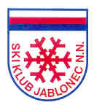
FIS Rollerski European Championships

and World Cup in Jablonec n.Nisou

20.6 – 22.6.2003

Competition Program

Thursday, June, 19th
10,00 – 15,00 o‘clock Accreditation
place: Areál Břízky, Sportovní 310,
Jablonec nad Nisou

20,00 o‘clock Team Information Meeting Drawing (proloque, sprint)
place: Town hall-Rathaus, Dolní náměstí
Jablonec n. Nisou

Friday, June, 20th

10,30 o‘clock Proloque in classical technique - start

Bílý Potok – Smědava
5 km, HD – 320 m

17,30 o’clock Sprint - qualification place: Břízky – „KOLEČKO“

20,30 o’clock Team Captains’ Meeting
place: Town hall-Rathaus, Dolní náměstí
Jablonec n. Nisou

Saturday, June, 21st
14,00 o’clock Pursuit – start
place: Jablonec - centre (Horní náměstí)
one lap - 3 km long
senior men - 10 laps
all other categories - 8 laps

17,00 o’clock Team Captains’ Meeting
place: Town hall-Rathaus, Dolní náměstí
Jablonec n. Nisou

Sunday, June, 22nd

9,30 o’clock Sprint – start : KO - system
place: Jablonec - Horní náměstí

ACCOMMODATION FORM
Address : SKI KLUB Jablonec nad Nisou,
Sportovní 310, 466 04 Jablonec nad Nisou
tel.:++420 483 705 860, tel./fax : ++420 483 705 590, ++420 483 705 325
E-mail : slcr.lyze.beh@pvtnet.cz

National Association : …………………………………………………….

We order accommodation

A/ in the centre of Jablonec nad Nisou YES NO
(in place of the race)
at the price of 35,- EU

B/ at the price of 25-30,- EU YES NO

C/ at the price of 15-25,- EU YES NO

with full board YES NO

Number of persons : Men …………………

Women …………………

Date of arrival ………………………………………………………………...

Date of departure …………………………………………………………….

Special requirements ………………………………………………………..

………………………………………………………………………………….

……………………………………..
Signature
ENTRY FORM (ICR Art. 217)
FORMULAIRE D'INSCRIPTION (RIS Art. 217)
ANMELDUNGSFORMULAR (IWO Art. 217)

Competition (Name/Place) FIS Rollerski European Championships  Manifestation (Nom/Lieu) JABLONEC NAD NISOU  Veranstatlung (Name/Ort) |  |  |  |  |  |  | Date of race 20.- 22.6. 2003  Date de la course  Datum des Wettkampfs
National Association |  |  |  |  |  |  | Cat. |  | WC | CC |  | F
Fédération Nationale |  |  |  |  |  |  | Cat. |  | COC | Fond |  | C
Nationaler Verband |  |  |  |  |  |  | Kat. |  | FIS | LL |  | Purs.
Responsible for entry |  |  |  |  |  |  | Tel.:
Responsable de l'incription |  |  |  |  |  |  | Fax:
Für die Meldung verantwortlich |  |  |  |  |  |  | E-mail:
COMPETITORS
COUREURS
WETTKÄMPFER
Code No. | Surname, First Name | Year | Category |  | Sex |  |  | Rollerski
N. de code | Nom de famille, Prénom | Birth
Code Nr. | Familienname, Vorname |  |  |  | Men | Ladies |  | Proloque |  |  | Sprint

Site/Lieu/Ort Date/Date/Datum Signature/Unterschrift
ENTRY FORM (ICR Art. 217)
FORMULAIRE D'INSCRIPTION (RIS Art. 217)
ANMELDUNGSFORMULAR (IWO Art. 217)

Competition (Name/Place) FIS Rollerski World Cup  Manifestation (Nom/Lieu) JABLONEC NAD NISOU  Veranstatlung (Name/Ort) |  |  |  |  |  |  | Date of race 20.- 22.6. 2003  Date de la course  Datum des Wettkampfs
National Association |  |  |  |  |  |  | Cat. |  | WC | CC |  | F
Fédération Nationale |  |  |  |  |  |  | Cat. |  | COC | Fond |  | C
Nationaler Verband |  |  |  |  |  |  | Kat. |  | FIS | LL |  | Purs.
Responsible for entry |  |  |  |  |  |  | Tel.:
Responsable de l'incription |  |  |  |  |  |  | Fax:
Für die Meldung verantwortlich |  |  |  |  |  |  | E-mail:
COMPETITORS
COUREURS
WETTKÄMPFER
Code No. | Surname, First Name | Year | Category |  | Sex |  |  | Rollerski
N. de code | Nom de famille, Prénom | Birth
Code Nr. | Familienname, Vorname |  |  |  | Men | Ladies |  | Proloque |  |  | Sprint

Site/Lieu/Ort Date/Date/Datum Signature/Unterschrift

OFFICIALS
OFFICIELS
OFFIZIELLE
Surname, First Name  Nom de famille, Prénom  Familienname, Vorname |  |  | Function  Fonction  Funktion |  | Arrival  Arrivée  Anreise | Departure  Départ  Abreise
Team Captain/Chef d'équipe/
Mannschaftsführer
 |  |  | Trainer/Entraîneur/Trainer
 |  |  | Doctor/Médecin/Arzt
 |  |  | Physiotherapist/Masseur/Masseur
 |  |  | Technicians/Techniciens/Techniker
 |  |  | Service personnel/Personnel de service/Servicepersonal
Place, Date  Lieu, Date  Ort, Datum |  | Signature:  Signature:  Unterschrfit:
Block letters please! | Ecrire en majuscules s.v.p. |  |  | Bitte in Blockschrift schreiben!
cs

